**Practical no. 7**

**Shivam Kumar**

**Roll No. 50**

A report categories and their required data will depend on the specific industry, organization, and purpose of the reports. However, I can provide a generalized list of common report categories and the typical data required for each.

**1. Financial Reports:**

* **Income Statement**: Revenue, expenses, net income.
* **Balance Sheet**: Assets, liabilities, equity.
* **Cash Flow Statement**: Operating, investing, and financing activities.

**Layout for CFO/Financial Analyst**:

* Detailed tables with financial metrics.
* Graphs or charts showing trends over time.

**2. Sales and Marketing Reports:**

* **Sales Performance**: Monthly/quarterly sales, top-selling products.
* **Marketing ROI**: Campaign costs, leads generated, conversion rates.

**Layout for CMO/Marketing Manager**:

* Pie charts showing market share.
* Line graphs for sales trends.
* Tables with lead generation metrics.

**3. Operational Reports:**

* **Inventory Levels**: Current stock, reorder levels.
* **Production Metrics**: Units produced, wastage.

**Layout for COO/Operations Manager**:

* Bar graphs for inventory turnover.
* Flowcharts showing production processes.
* Tables detailing operational efficiencies.

**4. Human Resources Reports:**

* **Employee Turnover**: Number of exits, reasons.
* **Performance Reviews**: Ratings, feedback.

**Layout for CHRO/HR Manager**:

* Tables with turnover rates.
* Scatter plots for performance distribution.
* Org charts showing team structures.

**5. Customer Service Reports:**

* **Customer Satisfaction**: Surveys, feedback.
* **Issue Resolution**: Number of tickets, resolution times.

**Layout for Customer Service Manager**:

* Pie charts for satisfaction ratings.
* Heatmaps for common issues.
* Tables detailing resolution metrics.

**6. Project Management Reports:**

* **Project Status**: Milestones achieved, pending tasks.
* **Resource Allocation**: Budgets, manpower.

**Layout for Project Manager**:

* Gantt charts for project timelines.
* Tables listing tasks, deadlines, and responsible parties.

**7. Compliance and Regulatory Reports:**

* **Compliance Audits**: Findings, corrective actions.
* **Regulatory Filings**: Submissions, deadlines.

**Layout for Compliance Officer**:

* Checklist-style layouts for audit findings.
* Timelines for regulatory submissions.

These are general categories, and the exact reports needed will vary based on the organization's nature, size, and industry. Customizing reports to fit specific needs and ensuring data accuracy are crucial for effective decision-making.

Top of Form

**Practical no. 8**

**Shivam Kumar**

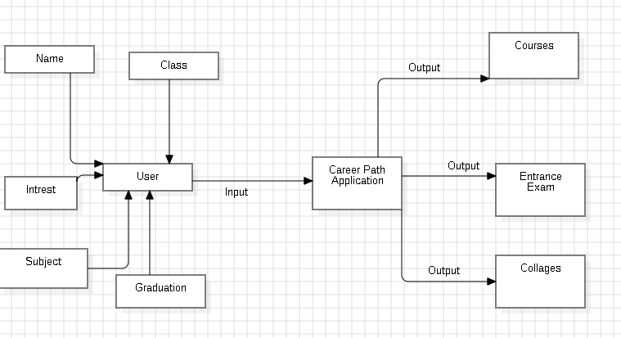

Functionalities of Use case:

**1. Name**

Courses

Entrance Exam

Collages

**2. Objective**

To provide best combination of Courses , Exam and Collages according to the student interest and his/her qualification.

**3.Precondiction & Postcondition**

It is necessary that student enter right information .

The results provided to the user should be exact.

**4) Normal Flow & Alternate Flow**

If the user is an entered right info he will reach upto the result interface.

If not the user will have an alternate flow to other interface stating, he is not.